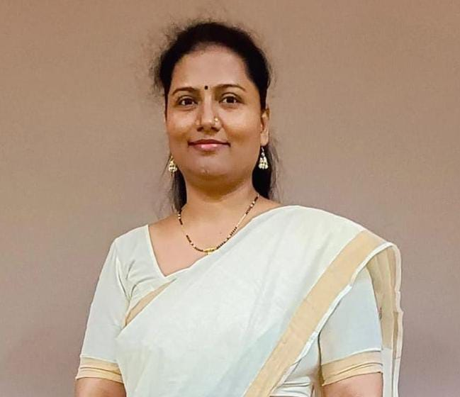

Prof. RENUKA NAGPURE

M.E. in Computer Engineering

B.E. in Information Technology

**Date of Birth :** 4th May 1985

**Qualification:**

|  |  |  |  |  |
| --- | --- | --- | --- | --- |
|  | Year of Passing | Passing Board/ University | % of Marks/ CGPA | Division |
| X | 2001 | SSC Board | 71.60 % | First |
| XII | 2003 | HSSC Board | 64.67% | First |
| BE(I. T) | 2007 | Nagpur University | 73 % | First |
| ME(Comp Engg) | 2014 | Mumbai University | 7.3 CGPA | First |

**Residential Address:** G-60, DariyaSagar, Bhulabhai Desai Road, Mahalaxmi Temple Compound, Mumbai-400026

**Email:** renuka.nagpure[@mctrgit.ac.in](mailto:anushree.deshmukh@mctrgit.ac.in)

**Contact Number:** 9892853135

**Designation**: Assistant Professor in Department of Information Technology

**Experience**: Educational 16.5 Years

**Areas of Interest:** Machine Learning, Data Mining, Artificial Intelligence & Data Science, Big Data, Networking, Query Expansion, IoT

**Publications Details:**

|  |
| --- |
| * Personal Finance Management App With Loan Default Risk Assessment Using EDA, Atharva Rane, Suhani Bhansali, Prachi Darji, Prof. Renuka Nagpure (ISSN-2349-5162) Journal of Emerging Technologies and Innovative Research 2025 |
| * Enhancing Security and Privacy in Book Exchanges with Blockchain Technology, Prof. Renuka Nagpure, Prof. Divya Gajangi, Prof. Dhanshree Bhanushali ISBN: 978-93-341-5647-8 International Conference on Science, Technology, Engineering & Mathematics for Sustainable Development (ICSTEMSD 2025) |
| * Optimizing User Satisfaction through WUM-based Online Recommendation Systems Enhanced by NLP Technology, Divya Gajangi, Renuka Nagpure, Dhanashree Bhanushali, Snehal Andhare ISBN: 978-93-341-5647-8 International Conference on Science, Technology, Engineering & Mathematics for Sustainable Development (ICSTEMSD 2025) |
| * Prediction of Colon Cancer Using Artificial Intelligence Comprehensive Review and Future Directions, Dhanashree Bhanushali,Divya Gaikvad, Renuka Nagpure ISBN: 978-93-341-5647-8 International Conference on Science, Technology, Engineering & Mathematics for Sustainable Development (ICSTEMSD 2025) |
| * INTERVERSE: Job and Internship Ecosystem Using Blockchain,Atharva Kadu,Ritesh Ishi, Romit kudu,Abhishek Gole, Renuka Nagpure, Snehal Gholap ISBN: 978-93-341-5647-8 International Conference on Science, Technology, Engineering & Mathematics for Sustainable Development (ICSTEMSD 2025) |
| * Ask Genie-Knowledge Representation System , Poonam Jadhav, Jitesh Kamble, Khushi Kashyap, Nisha Kendre, Renuka Nagpure,INDIAN JOURNAL OF TECHNICAL EDUCATION Volume 47 l Special Issue l No. 2 l February 2024 ISSN 0971-3034 Indian Journal of Technical Education (IJTE) Special Issues International Conference Theme: Science Technology Engineering & Mathematics for Sustainable Development (ICSTEMSD 2023) |
| * A Study on Open Source Server Technologies, Renuka Nagpure, Divya Gajangi, Dhanashree Bhanushali, INDIAN JOURNAL OF TECHNICAL EDUCATION Volume 47 l Special Issue l No. 2 l February 2024 * ISSN 0971-3034 Indian Journal of Technical Education (IJTE) Special Issues International Conference Theme: Science Technology Engineering & Mathematics for Sustainable Development (ICSTEMSD 2023) |
| * PATAPAY : Online Secure Payment Addressing System, Divya Gajangi, Renuka Nagpure, Sahil Gawli, Rohan Ingle, INDIAN JOURNAL OF TECHNICAL EDUCATION Volume 47 l Special Issue l No. 2 l February 2024 ISSN 0971-3034 Indian Journal of Technical Education (IJTE) Special Issues International Conference Theme: Science Technology Engineering & Mathematics for Sustainable Development (ICSTEMSD 2023) |
| * Block Chain based Book Exchange, Ashutosh Patil, Piyush Pal, Aditya Pal,Kishan Prajapati, Prof. Renuka Nagpure ISSN 0971-3034 Indian Journal of Technical Education (IJTE) Special Issues * International Conference Theme: Science Technology Engineering & Mathematics for Sustainable Development (ICSTEMSD 2023) |
| * AI generated Image Detection, Fariha Sheikh, Dhruv Modi, Vedant More,Nivedita Panda, Prof. Renuka Nagpure ISSN 0971-3034 Indian Journal of Technical Education (IJTE) Special Issues * International Conference Theme: Science Technology Engineering & Mathematics for Sustainable Development (ICSTEMSD 2023) |

**STTP_FDP_Workshop Details:**

|  |  |  |  |
| --- | --- | --- | --- |
| **FDP/STTP/Workshop** | **Name of FDP/STTP** | **No. of days** | **Date** |
| Online FDP | Intelligent Computing Techniques and its Engineering Application(ICTEA-2025) | One week | 6th Jan to 10 Jan 2025 |
| AICTE Training And Learning (ATAL) Academy Faculty Development Program at KPR Institute of Engineering and Technology | Empowering Healthcare with AI and ML: Advances and Applications | 6 days | 17/02/2025 to 22/02/2025. |
| One Week National Level Online Faculty Development Program | Generative AI Models anApplications of Machine Learning | One Week | 21-05-2024 to 25-05-2024 |
| FDP, HSNC University, Mumbai | AI for Educators | 10 Days | 3rd June to 12th June 2024 |
| Faculty Development Program at ASET COLLEGE OF SCIENCE & TECHNOLOGY, Chennai. | ChatGPT & AI tools for Academician | Online 5-Days | 27th November to 01st December 2023 |
| Certification Program | Data Science with data Visualization and R | Online 5-Days | May 27th to 31st 2024 |
| NPTEL- AICET FDP | Data Analytics with Python | 12 Weeks | Jan-Apr 2024 |
| ISTE Approved One Week STTP at Atharva College of Engineering | IoT in Industrial Automation | One Week | 24/06/24 to 29/06/24 |
| ISTE Approved Two Week STTP at Atharva College of Engineering | Full Stack Development using Java | Two Weeks | 18th Sep to 28th Sep 2024 |
| Online FDP | Generative AI and its multidomain uses cases | One week | 2nd Dec to 6th Dec 2024 |
| ISTE approved 2 week STTP at Atharva College of Engg | AI/ML AND DATA SCIENCE FOR HEALTH CARE | 2 Week | 11/12/23 to 22/12/23 |
| ISTE approved SF-STTP/FDP at Vidyalankar Institute of Technology, Mumbai, Maharashtra. | “Unearth The Secrets of  Natural Language Processing” | 5 Days | 26.06.2023 to 30.06.2023 |
| ISTE approved Online/SF-STTP/FDP at Atharva College of Engineering, Mumbai, Maharashtra. | “AIML & Data Science in Health  Care” | 2 Week | 11.12.2023 to 22.12.2023 |

**Professional Membership:**

ISTE (LM 108149 - Life Member)