IETE 2020-2021 CONDUCTED EVENTS’ LIST

Name of the webinars | Date | Conducted by/Speaker | No. of days
Symposium--  Beyond the Pandemic  (online panel discussion) | 9th august 2020 | Speakers :  1)Dr.Sanjay Bokade  2)Mr.Sandip Kadtane  3)Mr.P.Pentayya  4)Mr. Uday Bhaskarwar  5)Mr.Neeraj Shah  6)Mr.Devdatta V.Rokade  Conducted by :  IETE-RGIT and IEEE-RGIT | 1
Deep Learning | 12th September 2020 | Speaker :  Mr.Rahul Agarwal  Conducted by :  IETE-RGIT and RGIT’S Robotics Club | 1
Teachers Day | 13th September 2020 | Conducted by :  IETE-RGIT | 1
Proteus | 28th September 2020, 5th,12th,14th,15th,16th October 2020 | Speaker :  Mr.Karan Gupta  Conducted by :  IETE-RGIT | 6
BEGINNER’S TRAINING PROGRAM on Adobe Photoshop | 10th , 11th , 17th , 18th October 2020 | Speaker :  Mr. Abhijeet Bhise,  Miss. Crystal Fernandas  Mr. Ankit Bhowad  Conducted by :  IETE-RGIT | 4

Name of the webinars | Date | Conducted by/Speaker | No. of days
BDA(big data analytics) | 30th January 2021 | Speaker :  Mr. Sandeep Patil  Conducted by :  IETE-RGIT | 1
FE Induction | 6th February | Speakers :  IETE RGIT  IEEE RGIT  Conducted by :  EXTC Department | 1
SE Orientation | 18th February | Speakers :  IETE RGIT  Conducted by :  IETE RGIT | 1
Fundamentals of Electric Vehicle | 5th March 2021 | Speakers :  1) Mr. Karan Gupta 2)Mr.Vinayak Bhat  Conducted by :  IETE-RGIT and Team RGIT Racing | 1
BEGINNER’S TRAINING PROGRAM on Web Development | 27th , 28th march 2021 and 3rd april 2021 | Speakers :  1) Ms.Navya Sheregar  2) Ms.Pooja Palekar  Conducted by :  IETE-RGIT | 3
ONE MONTH INTERNSHIP PROGRAM on Backend Web Development | 4th april, 11th April, 18th April and 25th April 2021 | Speakers :  Mr. Rishi Gupta  Conducted by :  IETE-RGIT and Autumn Tech Labs | 1 month
Management Exams And Selection Process Webinar | 1st May 2021 | Speakers :  Ms. Deepika Awasthi  Conducted by :  IETE-RGIT and RGIT’s MESA | 1
Overview and Opportunities in VLSI Webinar | 15th May 2021 | Speakers :  Dr. Surendra Rathod  Conducted by :  IETE-RGIT | 1

Events conducted during 2019-2020
Sr.no | Name of the Event | Date | Speaker | About the event
1 | SE orientation | 24-07-2019 | Dr. S. D. Deshmukh | Second year students were briefed about the Department
2 | Texas IOT workshop | 19-08-2019 &  20-08-2019 | Prof. SahistaKhanum | Upcoming IOT trends were explained along with hands on practice.
3 | Proteus Software Workshop | 20-08-2019 | Vishal Thorat, Hitesh Humane, Nitesh Patel | Students were briefed about Proteus Software.
4 | Multisim Workshop | 06-09-2019 | Nitesh Patel, Hitesh Humane | A tutorial about Multisim workshop was conducted.
5 | Python Workshop | Stage  1:04-09-2019  2:01-10-2019 | Prof. Piyush Dave | Python was taught from scratch for the students.
6 | HFSS  Workshop | 04-02-2020 | Prof.S.R.Bhoyar | Students were given a brief about HFSS software used for antenna design
7 | Latex Workshop | 10-02-2020 | Mr. Sandeep Julai | Final years students were briefed about the latex software
8 | LTspice Workshop | 17-02-2020 | IETE members | SE students were given a idea about the software

Python Workshop
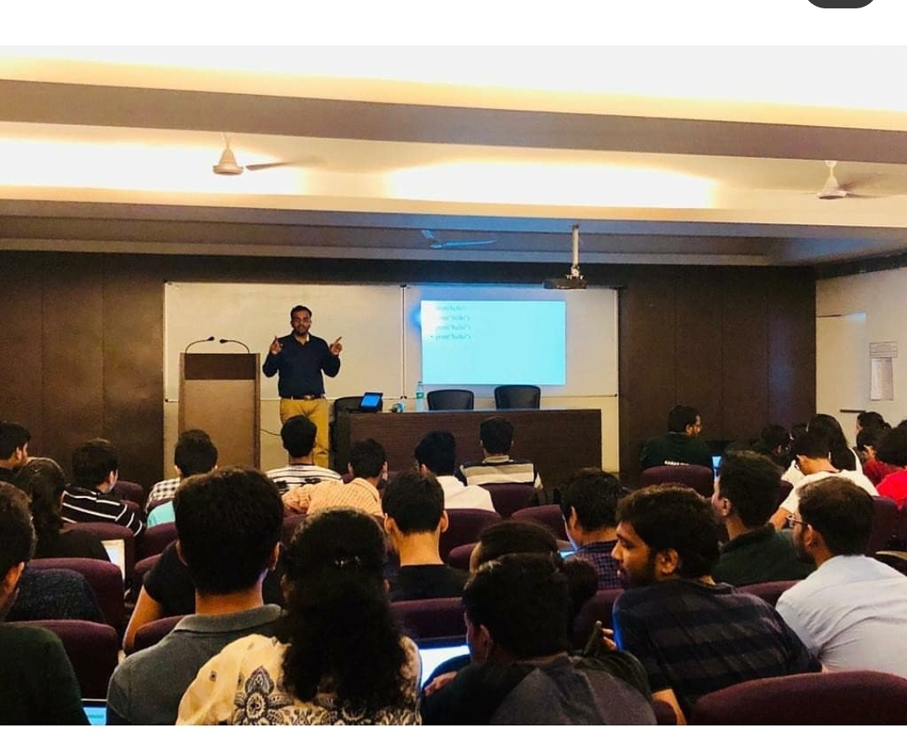
Texas IOT workshop
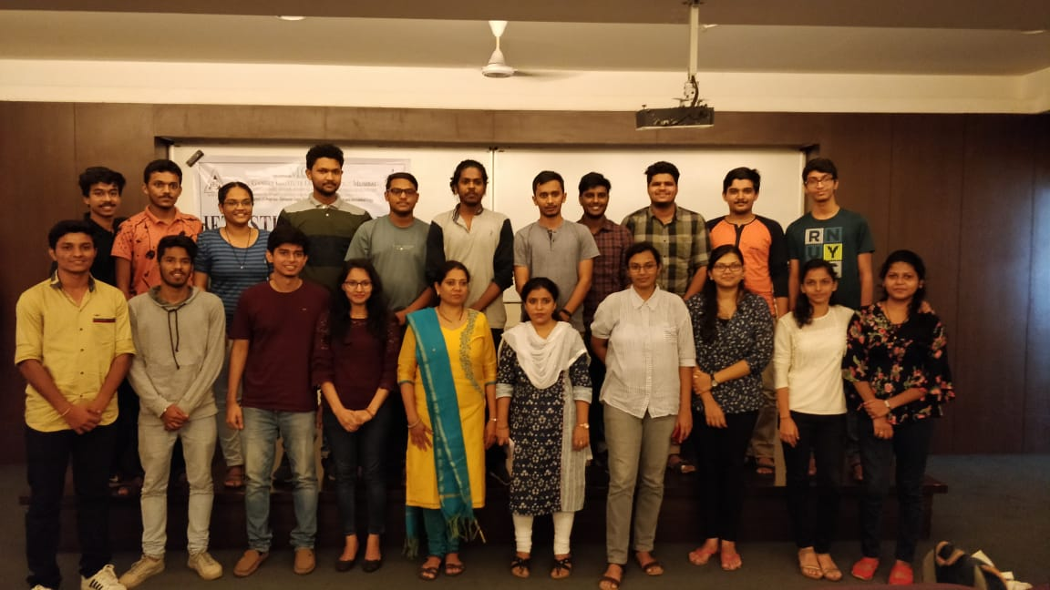
Proteus Workshop
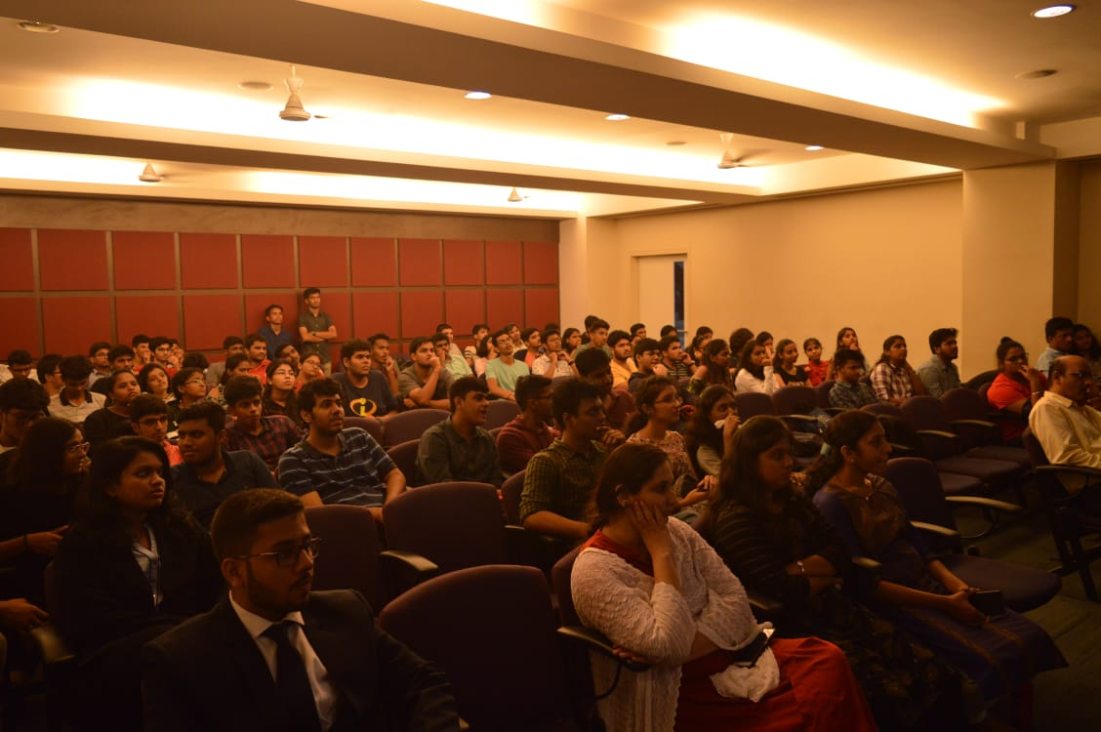

Workshop on Multisim
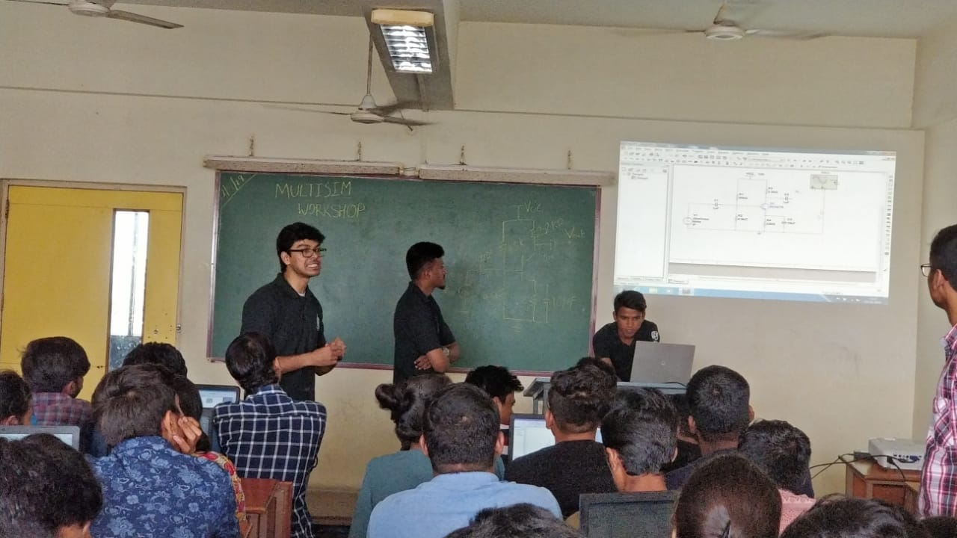

Events conducted list (Academic Year 2018-2019)

SR.NO | DATE | EVENT
1 | 25-Jul-18 | SE orientation
2 | 01-Aug-18 | FE orientation
3 | 10-Aug-18 | Proteus workshop for TE
4 | 21-Aug-18 | Home Automation workshop
5 | 06-Sep-18 | Proteus workshop for SE
6 | 03-Oct-18 to 05-Oct-18 | Machine Learning & Artificial Intelligence
7 | 29-January-2019 | LATEX workshop
8 | 4-February-2019 to 5-February-2019 | Python workshop
9 | 11-February-2019 | HFSS Workshop

Events conducted list (Academic Year 2017-2018)

SR.NO | DATE | EVENT
1 | 01-Aug-17 | FE orientation
2 | 8 &9-Aug-17 | Eagle Workshop for TE
3 | 21-Aug-17 | SE orientation
4 | 22-Aug-17 | InDesign Workshop
5 | 25-Sept-17 | IOT Workshop
6 | 15-January-2018 | LATEX workshop

ISF Faculty Coordinator H.O.D.
Prof. Surendra Sutar Dr. S. D. Deshmukh

