IETE Students Forum (ISF)
Establishment: 23rd June 2012
Vision:
Reaching the unreached and empowering the youth through Technical Education and Skill Development

Mission:
Advancement of Electronics, Telecommunication, Information Technology & other related disciplines; to contribute in nation's Human Resource & Infrastructure Development through our engineers

Aims & Objectives:
To promote the general advancement of Electronics & Telecommunication Engineering, Computer Science & Engineering, Information Technology and allied subjects & application of these (referred to as the discipline henceforth) and to facilitate the exchange of information and ideas on these subjects amongst IETE members:
For achieving these, IETE:
Organize conferences, symposia, workshops and brain-storming sessions involving all concerned professionals, students and industry associations for the advancement of the discipline
Provide a forum for discussion on national policies and to provide suitable inputs to policy makers.
Promote and conduct basic Electronics and Telecommunication Engineering and continuing technical education programmes on these subjects for human resource development.
Stimulate research and development in the microwave, radar and wireless technologies.
Facilitate formulation and implementation of national standard for products and services in the discipline.
Enlarge membership base and provide facilities to members to update their professional skills.
Bring out quality publications for all levels of readership.
Honour outstanding professionals.
Organise resource centres and data bases.
Facilitate inter-disciplinary interaction with other organisations and individuals within and outside the country for the promotion of the discipline.
Develop the Institution's infrastructure at various centres and expand their activities.

ISF Faculty Coordinator H.O.D.
Prof. Surendra Sutar Dr. S. D. Deshmukh

IETE TEAM 2020-21
Core Team:
NAME | YEAR | POST
Jahnavi Kodakandla | BE | Chairperson
Shubham Bhagwat | BE | General Secretary
Anant Dev | BE | Vice-Chairperson
Komal Dongare | BE | Joint Secretary
Ankit Bhowad | BE | Treasurer

Technical Team:
NAME | YEAR | POST
Nimish Jadhav | Secretary | BE
Karan Gupta | Secretary | BE
Abhijeet Bhise | Asst.Secretary | TE
Sakshi Mankar | Head | TE.
Saylee Surve | Head | TE
Rohini Chavan | Head | TE
Swetali Vanjare | Head | TE
Suraj Patro | Team Member | TE
Anurag Rai | Team Member | TE
Shubham Patil | Team Member | TE
Jaya Verma | Team Member | SE
Abhishek Halpati | Team Member | SE.
Harshal Gidh | Team Member | SE
Akshata Teli | Team Member | SE
Shruti Anil Vani | Team Member | SE
Sunil Kanhiya Gaikwad | Team Member | SE
Gaurav Kamble | Team Member | SE
Manish Yadav | Team Member | SE
Yash Mestry | Team Member | SE
Jai Padaya | Team Member | SE

Digital Creative Team:
NAME | YEAR | POST
Crystal Fernandes | Secretary | BE
Ashika Kumar | Asst.Secretary | TE
Rohit Ahire | Head | TE
Abhijeet Bhise | Team Member | TE
Harshita Kulal | Team Member | TE
Prachiti Ghodane | Team Member | TE.
Kanishka Mohapatra | Team Member | TE
Akshata Teli | Team Member | SE
Janhavi Lad | Team Member | SE
Siddhi Vengurlekar | Team Member | SE
Devdatta Indulkar | Team Member | SE
Shruti Anil Vani | Team Member | SE

Event Management Team:
NAME | YEAR | POST
Tanvi Dongarikar | Secretary | BE
Shrutika Dhule | Secretary | BE
Chaitali Sumbe | Asst.Secretary | TE
Hemant Koyande | Head | TE
Janhavi Sakat | Head | TE
Vinay Chaukate | Head | TE
Harshita Kulal | Head | TE
Kashish Koli | Team Member | TE
Jayesh Vanmare | Team Member | TE
Ravi Jogdand | Team Member | TE
Suraj Patro | Team Member | TE
Jyoti Sharma | Team Member | SE.
Aavishkar Samant | Team Member | SE.
Radhika Shetty | Team Member | SE.
Janhavi Lad | Team Member | SE
Siddhi Vengurlekar | Team Member | SE
Devdatta Indulkar | Team Member | SE
Yash Mestry | Team Member | SE

Database Team:
NAME | YEAR | POST
Vedika Patil | BE | Database Secretary
Farnad Parekh | BE | Database Head
Nidhi Pawar | TE | Database Assistant Sec.
Sakshi Mali | TE | Database Head
Shubham Patil | TE | Database Member
Radhika Shetty | SE | Database Member
Manish Yadav | SE | Database Member

Publicity and Marketing Team:
NAME | YEAR | POST
Pooja Singh | BE | Publicity and Marketing Sec.
Yuvraj Pathak | BE | Publicity and Marketing Sec.
Sejal Agarwal | TE | Publicity and Marketing Assistant Sec.
Atharva Kulpe | TE | Publicity and Marketing Assistant Sec.
Nabhika Vartak | TE | Publicity and Marketing Head
Priya Gorade | TE | Publicity and Marketing Head
Siddhi Vengurlekar | SE | Member
Yash Mestry | SE | Member
Jai Padaya | SE | Member

ISF Photography:
NAME | YEAR | POST
Rohit Ahire | TE | Photography Head
Devdatta Indulkar | SE | Photography member
Radhika Shetty | SE | Photography member

Representatives:
Name | Year | Post
Jyoti Sharma | SE | SE Representative
Abhishek Halpati | SE | SE Representative

IETE 20-21 LIST OF EVENTS
ODD SEM-7

Name of Webinars | Date | Speaker/Conducted By | No. Of Days
Symposium --- Beyond the Pandemic (online panel discussion) | 9th August 2020 | Speakers:  1)Dr. Sanjay Bokade  2)Mr. Sandip Kadtane  3)Mr. P. Pentayya  4)Mr. Uday Bhaskarwar  5)Mr. Neeraj Shah  6)Mr. Devdatta V. Rokade  Conducted By:  IETE-RGIT and IEEE-RGIT | 1
Deep Learning | 12th September 2020 | Speaker:  Mr. Rahul Aggarwal  Conducted By:  IETE RGIT and RGIT’s Robotics Club | 1
Teacher’s Day | 13th September 2020 | Conducted by:  IETE-RGIT | 1
Proteus | 28th September 2020  5th,12th,14th,15th,16th October 2020 | Speaker:  Mr. Karan Gupta  Conducted by:  IETE-RGIT | 6
BEGINNER’S TRAINING PROGRAM on Adobe Photoshop | 10th,11th,17th ,18th October 2020 | Speaker:  Mr. Abhijeet Bhise  Ms. Crystal Fernandes  Mr. Ankit Bhowad  Conducted by:  IETE-RGIT | 4
EVEN SEM-8
Name of Webinars | Date | Speaker/Conducted by | No. of days
BDA (Big Data Analytics) | 30th January,2021 | Speaker:  Mr. Sandip Patil  Conducted by:  IETE-RGIT | 1
FE INDUCTION | 6th February 2021 | Speaker:  Dr. Sanjay Deshmukh  Prof Surrendra Sutar  Dr. Jayant Mahajan  IETE RGIT  IEEE RGIT  Conducted by:  IETE RGIT  IEEE RGIT | 1
SE ORIENTATION | 18th February 2021 | Speaker:  Dr. Sanjay Deshmukh  Prof Surrendra Sutar  IETE RGIT  Conducted by:  IETE RGIT | 1
Fundamentals of Electric Vehicles | 5th March,2021 | Speakers:  1)Mr. Karan Gupta  2)Mr. Vinay Bhatt  Conducted by:  IETE-RGIT and Team RGIT Racing | 1
BEGINNERS TRAINING PROGRAM on Web Development | 27th,28th March 2021  3rd April, 2021 | Speakers:  1)Ms. Navya Sheregar  2)Ms. Pooja Palekar  Conducted by:  IETE-RGIT | 3

SYMPOSIUM
BEYOND THE PANDEMIC
9th August, 2020
Speakers: Dr. Sanjay Bokade Total participant count: 110
Mr. Sandip Kadtane Youtube stream: 300-400 viewers
Mr. P. Pentayya
Mr. Uday Bhaskarwar
Mr. Neeraj Shah
Mr. Devdatta V. Rokade

The online panel discussion 'Symposium- Beyond the Pandemic...Knowledge, Recession and much more ' was held live on 9th August 2020 online on Zoom and YouTube platform. The event was the fruitful outcome of the collaboration of the IETE student forum in association with IEEE RGIT. The event was hosted by Dr. Jyoti Deshmukh. The interaction between faculty members, students, and Panel guest speakers made the event successful. The event's start was marked by the warm welcome of all students and faculty as well as panel guests by the event host.
Further to which honorable principal Dr. Sanjay Bokade, delivered few words and initiated the event. Honorable vice-principal and HOD of EXTC department Dr. Sanjay Deshmukh expressed his gratitude and views over the ongoing pandemic.
IETE ISF conveyor Prof. Surendra Sutar gave brief details about events and workshops conducted by IETE RGIT.
Later, the event was further led towards panel discussion where the first speaker Mr. Sandip Kadtane, founder of Cientra presented webinars on VLSI and embedded technologies and start-ups in India. Second speaker Mr. P.Pentayya, Director of DNH power distribution co. Ltd shared his knowledge on employment in government institutes in the private sector & its battle with covid 19. The next panel discussion was on Career options in the IT industry which was presented by Mr. Uday Bhaskarwar, CEO of Thinking Hut, Pune. Mr. Neeraj Shah, Owner & CEO of Silver Bright highlighted his aspects in entrepreneurship. Furthermore, Mr.Devdatta Rokade, Head of Digital Banking, Mumbai talked about careers in banking & management sectors & the effects of covid 19 on finance.
After all the information was provided, a question-answer session was conducted where students cleared their doubts with panel guest speakers. Further to the student’s interaction session, a vote of thanks was delivered by Dr. Jayant Mahajan, which was later marked with the end of the event.
Approximately, there were 90 participants attending the webinar on the Zoom platform and the live YouTube stream had a massive amount of 300-400 viewers.

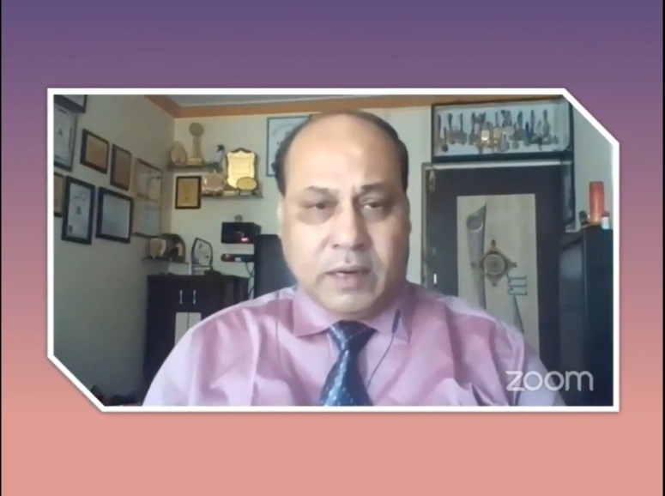

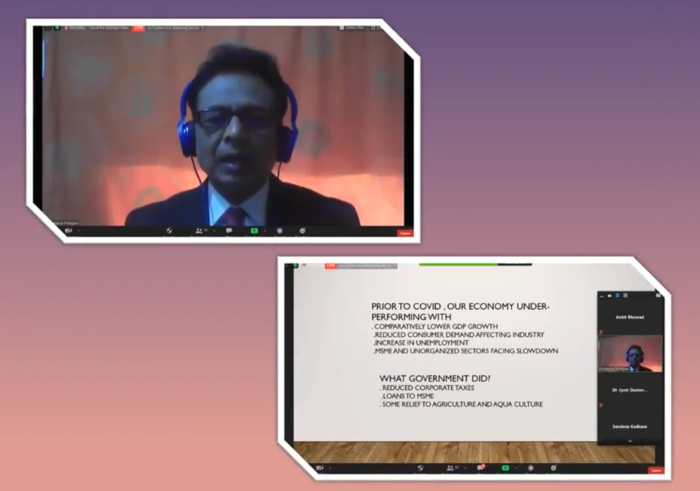
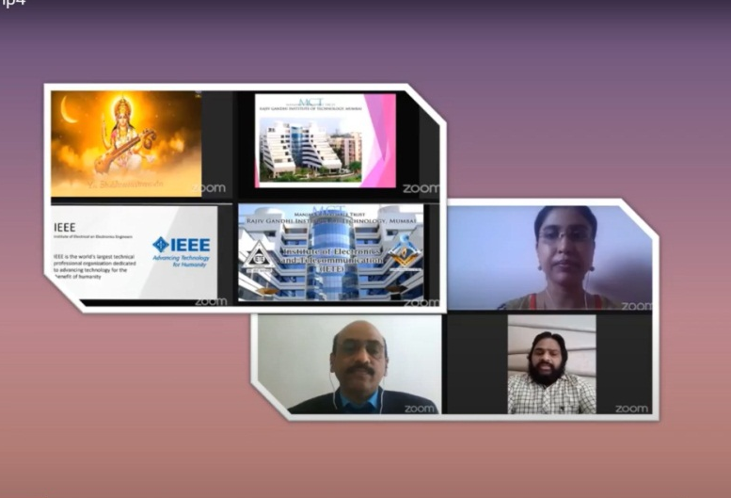

RGIT’s principal Dr. Sanjay Bokade sir, and all the honorable guest speakers giving presentations and discussing about various mentioned topics

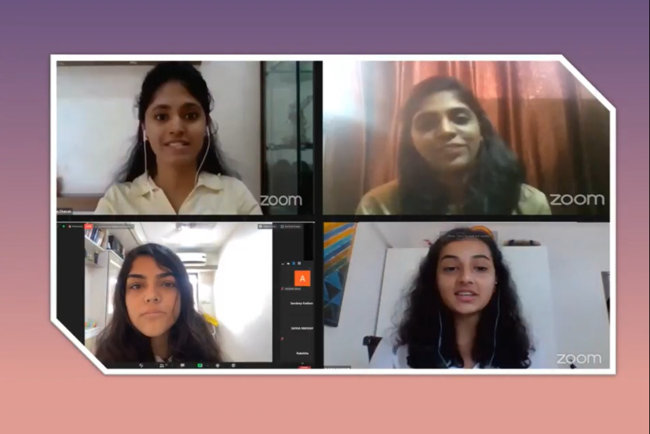
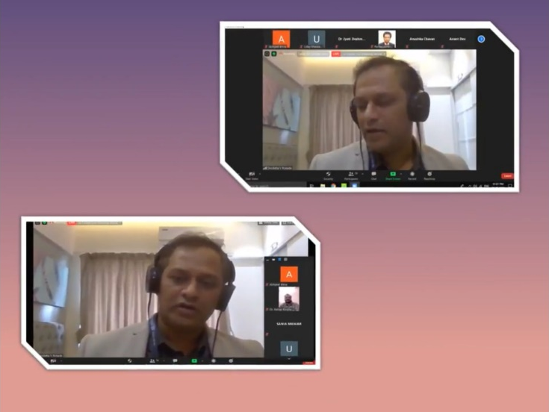

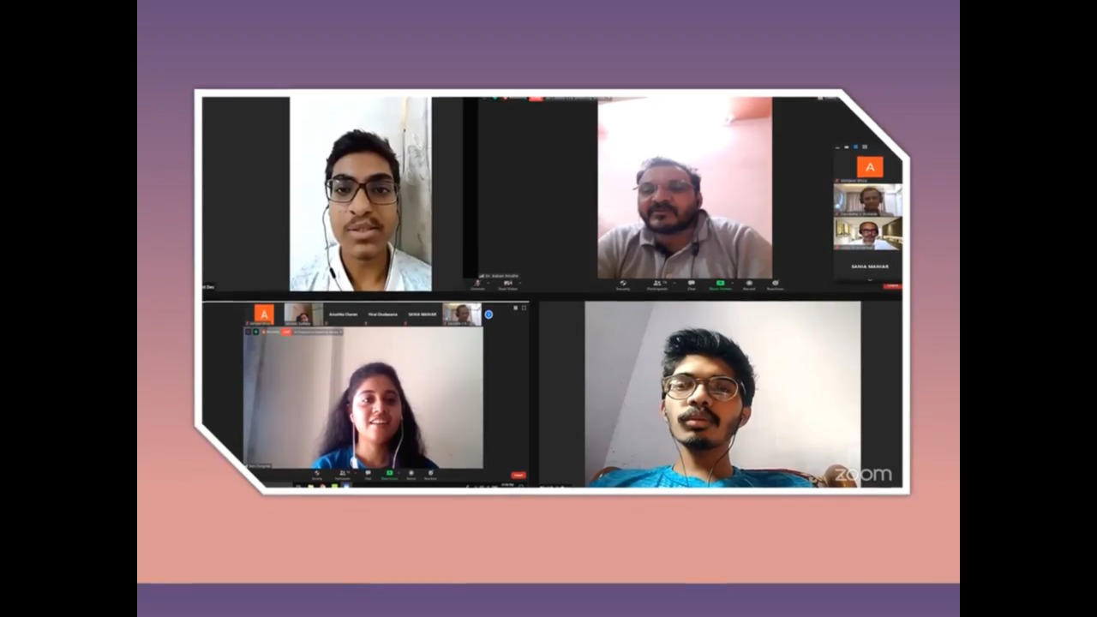
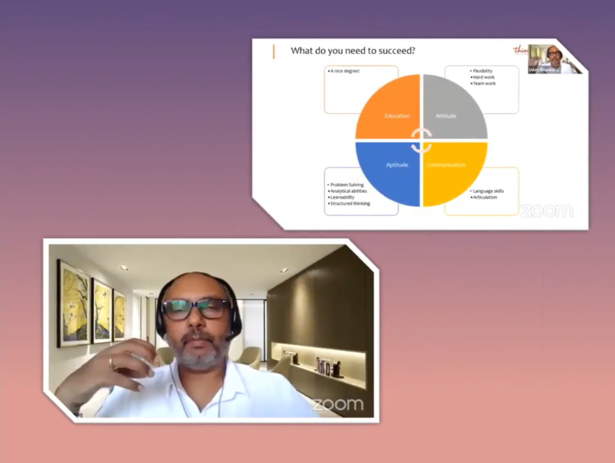

The QnA session after the panel discussion thriving with students actively asking their questions and panel members answering them

WEBINAR
DEEP LEARNING
12th September,2020
Speaker: Mr. Rahul Agarwal Total participant count:110
The Webinar 'Deep learning’ was held online on 5th September 2020 on Google meet and YouTube platform. The Webinar was in collaboration with Robotics club RGIT. The speaker for the event was Mr. Rahul Agarwal, Principal Machine learning manager at Microsoft.
The Webinar began at 5 pm sharp and many deep learning enthusiasts willing to grasp knowledge participated on respective online platforms. Abhishek Jagushte, Robotics club host initiated the event and warmly welcomed all the students as well as faculty members present for the webinar. Without further delay , the speaker Mr. Rahul Agarwal started sharing his presentation on deep learning and Natural language processing. Meanwhile, Mr. Rahul Agarwal was facing severe Network issues because of which it was difficult to carry on the webinar smoothly. After several trials , the webinar was finally rescheduled on 12th September 2020 .
All the participated students and members were quite supporting and with the same number of crowd even after rescheduling , the webinar started with a bang on 12th September sharp at 5pm. A brief introduction for the speaker was given by Abhishek Jagushte, Robotics club and the webinar was initiated by Mr. Rahul Agarwal. He was invited for talk on Deep learning and Natural language processing at IIT Kanpur.
An insightful presentation was shared by Mr. Agarwal and everyone was enthralled by listening to his in-depth approach on the respected topics. Topics such as Deep neural networks, Natural language processing, Industry applications of deep learning etc. were covered during this informative session.
As the presentation came to an end, A question answer session was conducted by the students for the participants and was hosted by Nidhi Pawar ,Database Asst. Sec, IETE RGIT. The event witnessed a whopping 110 participants.
Avadhoot Khedekar, President of Robotics club expressed a sincere vote of thanks and hence concluded the event.

Mr. Rahul Agrawal conducting the session via Google Meet
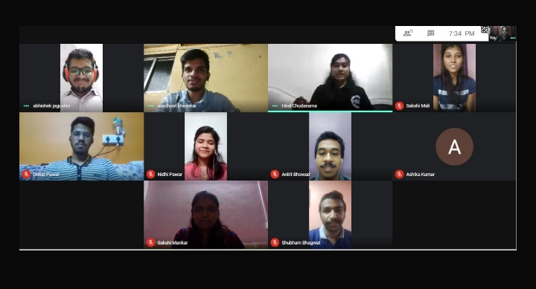

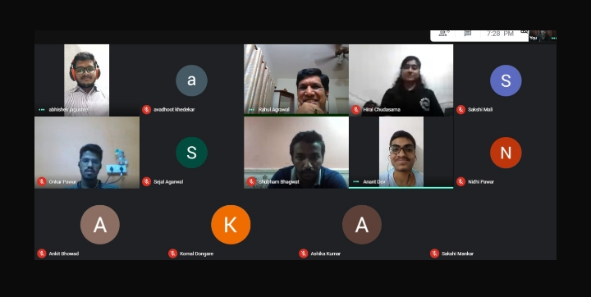

Members of IETE and Robotics Club with Rahul sir
CELEBRATION

TEACHER’S DAY

13th September 2020

Conducted by: IETE RGIT Total participant count: 50

Amidst the present crisis of Covid-19, IETE ISF RGIT’s batch of 2020-21 successfully hosted the teacher’s day event live on Google Meet for Electronics and Telecommunication department’s faculty members. Active participation by students and co-operations by faculty resulted in a smooth flow of this event.
The event was initiated by Chairperson of IETE 2020-21 Miss. Jahnavi Kodakandla, presenting her grateful words towards our teacher’s efforts to cope up with this pandemic and encourage students to continue with the teaching-learning process. All the attempts from teachers of adapting digital methods of teaching were highly appreciated. Next Ms. Nabhika Vartak, host of the event, expressed few words of appreciation on behalf of all the students. Further on, Mr. Rajas Dongre presented a soulful song with his melodious voice. After that Mr. Siddhiraj Bhayade presented a marvellous composition in Marathi shedding light over the student-teacher bond. Next Miss. Pooja Singh began her performance with a Doha by Saint Kabir Das and proceeded to deliver a beautiful poem in Hindi. Touched by the efforts of students HOD of EXTC Department Dr. Sanjay Deshmukh expressed his happiness towards the sincerity of the students. Dr. Poonam Sonar was next to praise the students and IETE for this unexpected event and expressed her gratitude. Next, Prof. Sushant Gothankar presented a touching Marathi composition, furthermore encouraging students.
The event ended with Miss. Jahnavi delivering a vote of thanks to all the students and faculty members present for the event. Roughly there were 50 people who were present during the event.
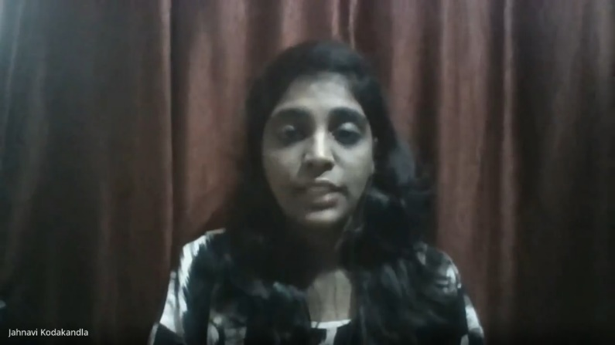

Miss Jahnavi Kodakandla welcoming all the teachers and initiating the day by expressing her gratitude
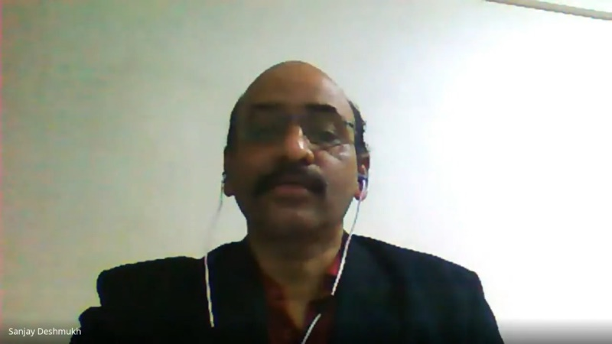

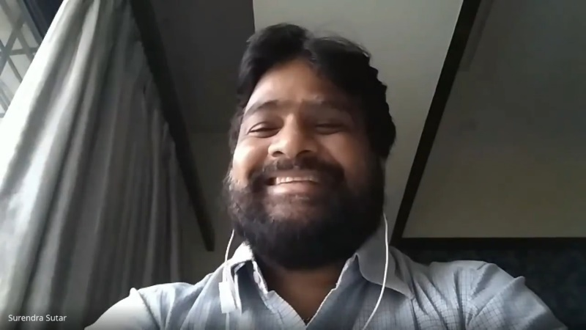

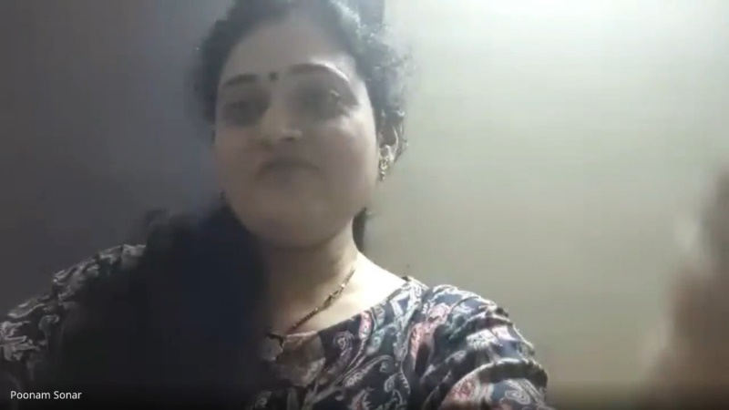

HOD of EXTC Dr. Sanjay Deshmukh sir, convener of IETE Prof. Surendra Sutar sir and Prof Poonam Sonar ma’am expressing their thoughts on the occasion of Teacher’s day

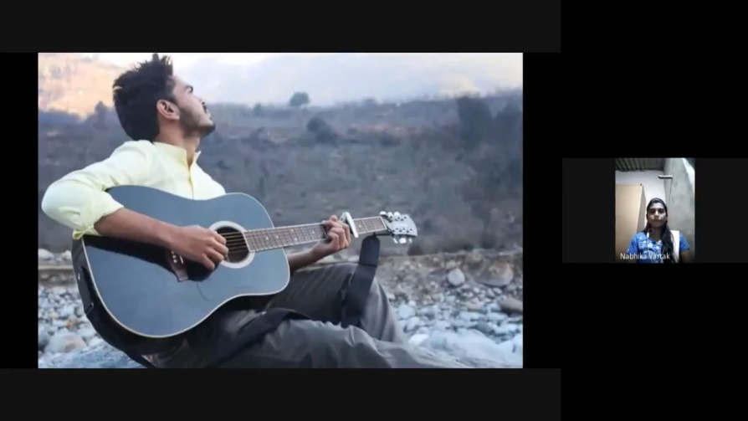

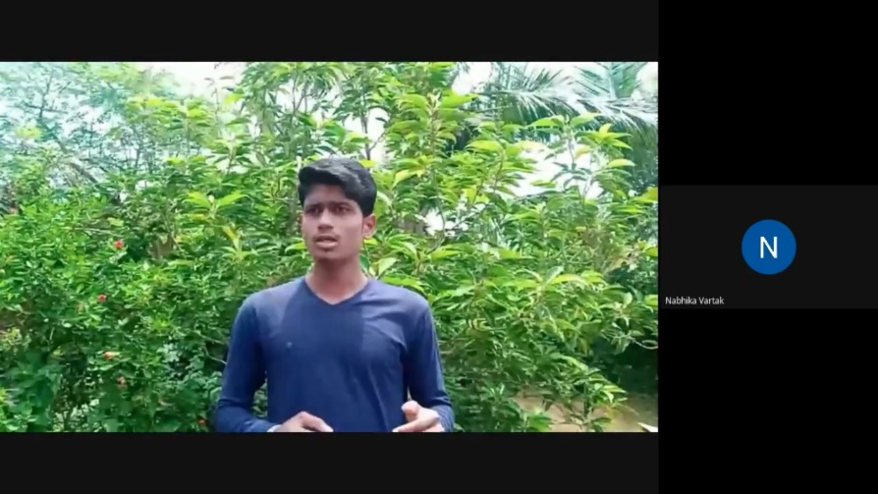

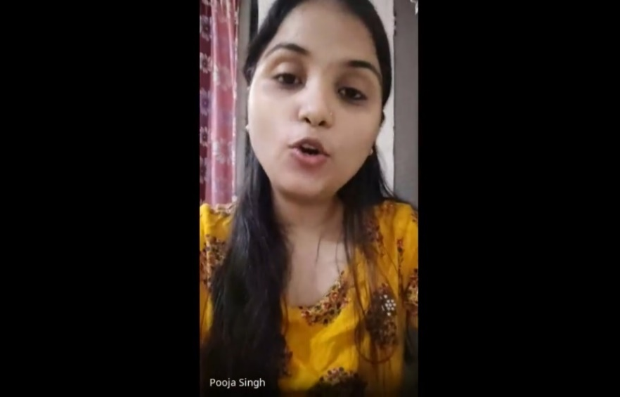

Mr. Rajas Dongre, Mr. Siddhiraj Bhayade and Miss Pooja Singh presenting their compositions while showing their appreciation to our teachers
WORKSHOP
PROTEUS
Day 1: 12th September 2020
Day 2: 5th October 2020
Day 3: 12th October 2020
Day 4: 14th October 2020
Day 5: 15th October 2020
Day 6: 16th October 2020

Speaker: Mr. Karan Gupta Total participant count: 60
The IETE Technical team conducted a 6-day workshop on PROTEUS software exclusively for the second-year students of EXTC department at Rajiv Gandhi Institute of Technology, Andheri (w).The session was taught by IETE Technical Secretary Mr. Karan Gupta. The beginning of the event was marked by warm welcome of all participants by the event host. The event was held on 28th of September, 5th, 12th,14th,15th and 16th of October on Google Meet platform.
This 6-day schedule was divided into different topics such as Installation procedure, Regulator Circuit Design , Regulator Circuit PCB Layout, 555 IC Circuit Design(Monostable mode) and 555 IC Circuit PCB Layout. Along with all these topics the students were given a brief idea on how to use ARDUINO Boards in Proteus. This workshop would provide a helping hand for the students with regards to their simulation related mini projects.
After that a special doubt solving session was conducted separately after the second session. Following each session there was a google form circulated which included questions regarding that particular session. A total number of students present during the workshop were around 60.The overwhelming response from SE students was the real success of the Proteus Workshop.
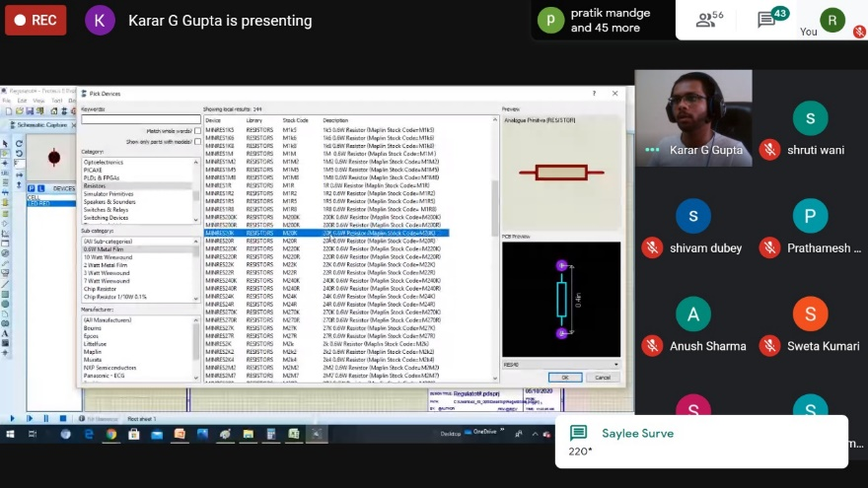

Proteus session for SE students conducted by IETE

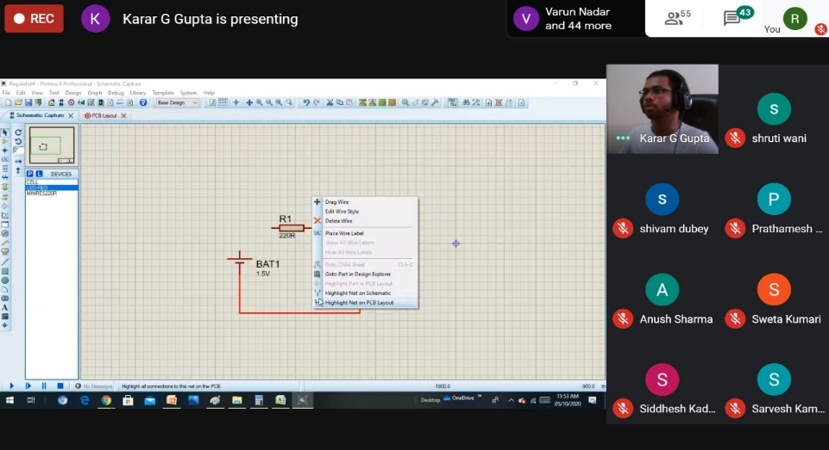

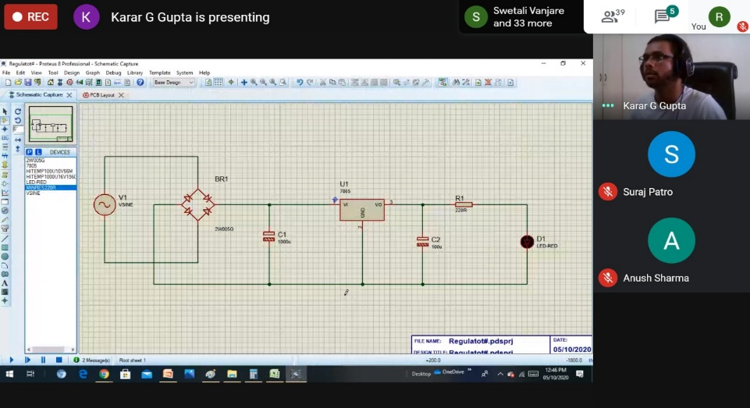
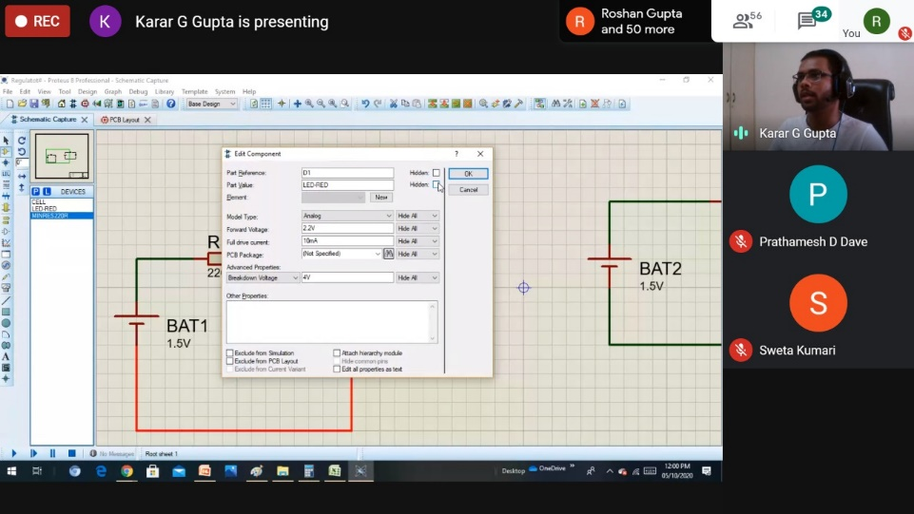

Mr. Karan Gupta engaging the sessions while teaching simulation and building circuits on Proteus simulation application
BEGINNER’S TRAINING PROGRAM
ADOBE PHOTOSHOP
Day 1: 10th October 2020
Day 2: 11th October 2020
Day 3: 17th October 2020
Day 4: 18th, October 2020

Speakers: Mr. Abhijeet Bhise Total participant count: 150
Miss Crystal Fernandes
Mr. Ankit Bhowad
BTP is an initiative where we train students to use various software and develop their skillset. As we like to call it, BTP is a program of a student, for a student, by a student.The very first theme of BTP was Adobe Photoshop. The event host welcomed all the participants with warmth.
BTP was conducted on 10th, 11th, 17thand 18th of October 2020 on Google Meet platform. The event was initiated by Ms. Crystal Fernandes. Mr. Abhijeet Bhise was speaker for day one, two and three. On day four , Mr. Ankit Bhowad and Ms. Crystal Fernandes were speakers. The interaction between participants and speakers made the event successful. On the First day there were two batches and on that day installation process and steps, interface introduction, panel and workspaces navigation, common files, dimension, resolution etc. were taught. On the second day Tools and Tabs were demonstrated. On day three Remaining tools were explained. On last day Hands on poster making, Hands on certificate and datasheet, variable clipping mask and watermark removing etc was explained.
Every day participants cleared their doubts with speakers. The number of people who participated in the event was about 150. The event ended with Ms. Jahnavi Kodakandla, IETE Chairperson delivering a vote of thanks to all the participants present for the event.
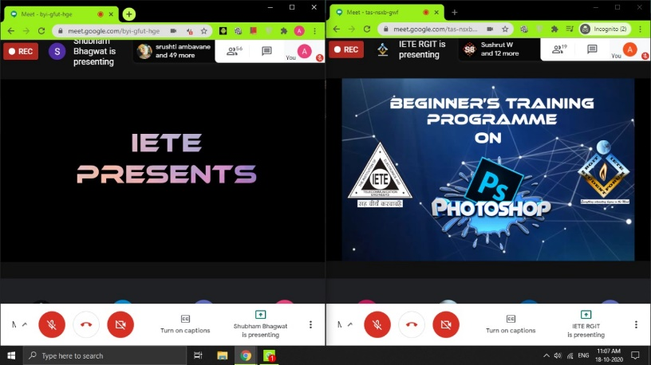

BTP on Adobe Photoshop via Google Meet

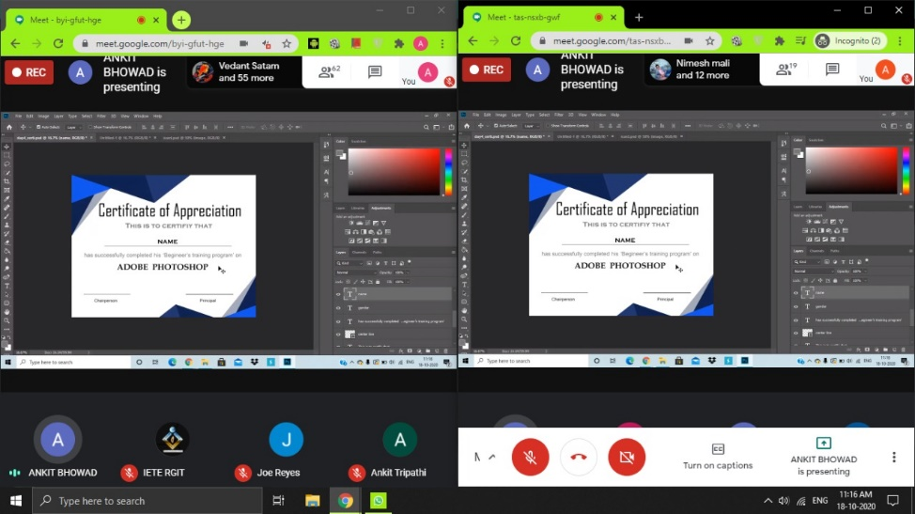

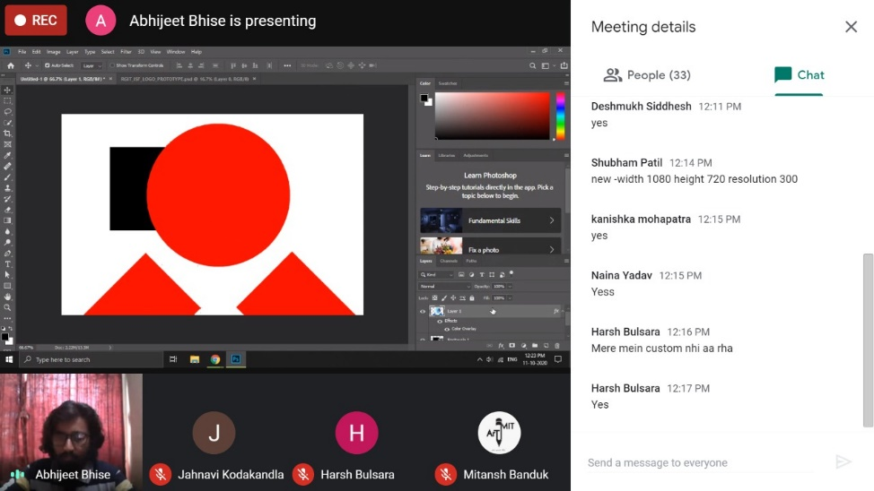

Mr. Abhijeet Bhise, Miss Crystal Fernandes and Mr. Ankit Bhowad; IETE members; conducting the session while teaching all the basics of photoshop and implying them using Adobe Photoshop

WEBINAR
BIG DATA ANALYTICS (BDA)
30th January 2021
Speaker: Mr. Sandip Patil Total participant count: 80
YouTube stream: 30-40 viewers

Introduction to Big Data Analytics webinar was conducted on 30thJanuary 2021 on Google Meet and YouTube platform. The event was initiated by Ms. Nabhika Vartak. Mr. Sandip Patil was speaker for the webinar.
He is a big data consultant at technological geeks and has a YouTube channel with more than 18k+ subscribers. He has experience as a big data consultant in CRB Tech solutions pvt. Ltd. And working as a Hadoop developer at Winjit Technologies Pvt. Ltd. The webinar’s start was marked by warm welcome of all participants by the event host, Miss. Nabhika Vartak. Then IETE convener Prof. S. T. Sutar also greeted to all the participants and speaker. Sandip sir explained in detail about the big data analytics and various opportunities in these field like Data Analyst, Data engineer.
The event was also live telecasted on IETE RGIT’s YouTube channel as well as on Mr. Sandip Patil’s YouTube channel (TG117).
At the end in QNA session participants cleared their doubts with speakers. Ms. Sejal Agarwal was there to convey the participants query to the speaker. The interaction between nearby 80 participants and speaker made the webinar successful.
The webinar ended with IETE chairperson Ms. Jahnavi Kodakandla delivering a vote of thanks to all the participants and speaker present for the event.
.
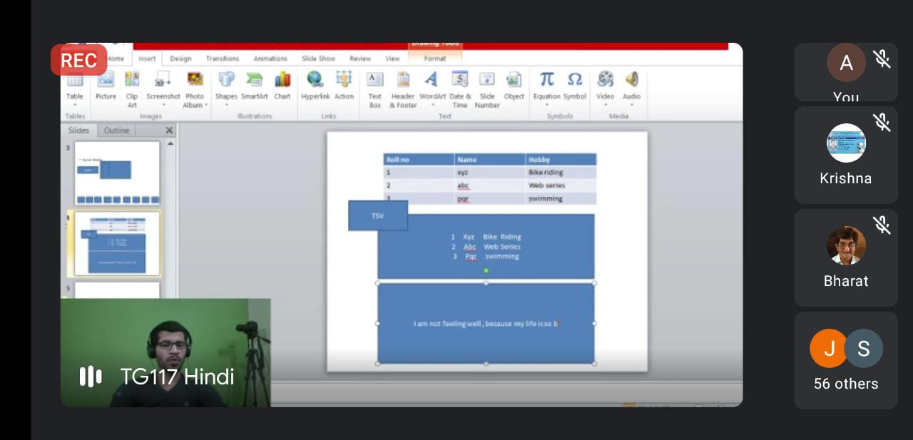

Mr. Sandip Patil giving a presentation and explaining basics of BDA

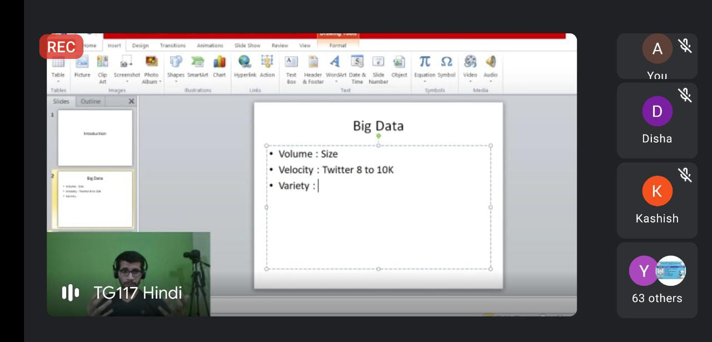

Sir further briefs about BDA

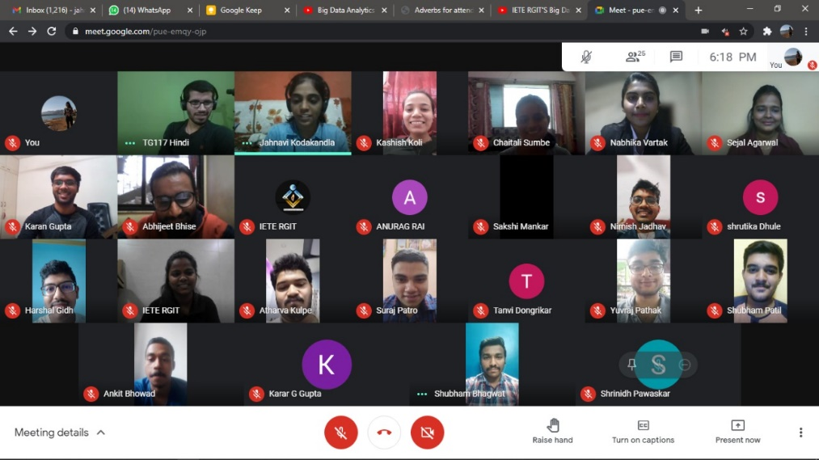

IETE members and Mr. Sandip Patil
ORIENTATION
FOR FIRST YEAR STUDENTS
Date: 6th February 2021
Conducted by:- 1)IETE RGIT Total participant count:-120
2)IEEE RGIT

'FE induction' was held on 6th February 21 online on Zoom Platform. The event was fruitful outcome of collaboration of IETE student forum and IEEE RGIT. The event was hosted by Ms. Twinkle and Ms. Nidhi. The interaction between faculty members, FE students and IETE student forum made the event successful.
The event's start was marked by warm welcome of all FE students and faculty members by the anchors. The Vice-Principal, RGIT and Head of Department EXTC, Dr. Sanjay Deshmukh gave a brief introduction about the EXTC department to FE's .Followed by this, the IEEE RGIT Convenor , Dr. Jayant Mahajan engaged with the students and introduced them to various aspects of IEEE RGIT. Professor Surendra Sutar, IETE RGIT Convenor then introduced the IETE student forum to first year students and enlightened them on the need of being part of the committee. He spoke about the importance of technical knowledge throwing light on various workshops that IETE conducts. He briefed the students about various opportunities provided by IETE.
Later, IEEE Publicity Secretary Adeena and host Twinkle, introduced and briefed about the activities organised by their committee IEEE in the past. Further on, IETE Database Asst.Sec Nidhi Pawar and Publicity Secretary Yuvraj Pathak briefed about the activities organised by IETE which included workshops, events , industrial visits etc. through a Presentation. The IETE committee also invited the EXTC Alumni Mr. Kunal Pawar who shared his experience in this department with the first-year students. The students were given virtual AS&H departmental tour by IEEE and EXTC departmental tour by IETE.
After all the information was provided, our National Anthem was played which marked the end of event.
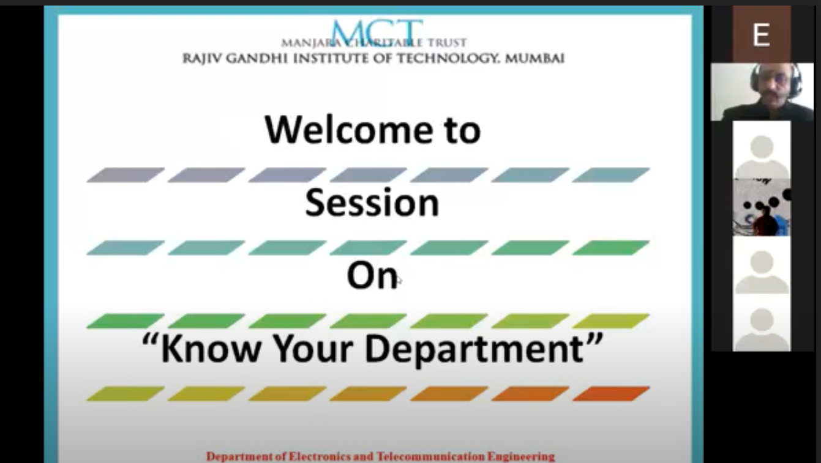
Vice principal and HOD of EXTC, Dr. Sanjay Deshmukh Adressing the students

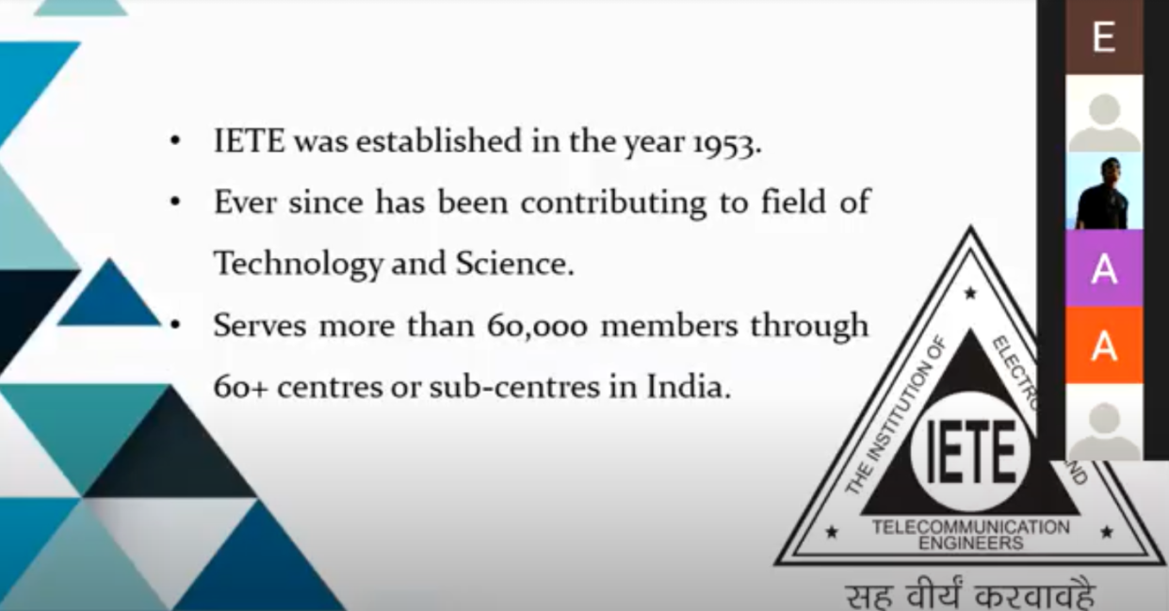
IETE Presentation

ORIENTATION
FOR SECOND YEARS
Date: 18th February 2021
Conducted by:- IETE RGIT Total participant count:-90-100
IETE RGIT successfully hosted SE orientation for the students of Second Year on Zoom. The active involvement of the students made the event a big hit.
The event was started off by Ms.Nidhi Pawar greeting the students and the faculty members. Next, the Vice Principal and Head of Department EXTC, Dr. Sanjay Deshmukh addressed the SEs and welcomed them, following which, he gave a brief information about our EXTC Department. Afterwards, our Convener of IETE RGIT, Prof. Surendra Sutar shared details about IETE RGIT.
Later, an elaborate Department Introduction video was presented for the students to fill them in about the various laboratories and classrooms. Miss Sakshi Mankar,IETE Technical Head, Mr. Karan Gupta, IETE Technical Sec and Miss Jahnavi Kodakandla, IETE Chairperson gave a brief idea about the committee and acquainted thestudents with the Core team and the team members. Further the students wereenlightened about various activities conducted by IETE Student Forumwhich included workshops, fest, events , industrial visits etc. Ms. Jahnavi Kodakandla familiarized them with our newly introduced
initiative ‘Beginner’s Training Program’.A vote of thanks was delivered by the chairperson of IETE RGIT, Miss.Jahnavi Kodakandla and thereafter concluding the SE orientation.
There was an interactive session conducted among the students informally towards the end.

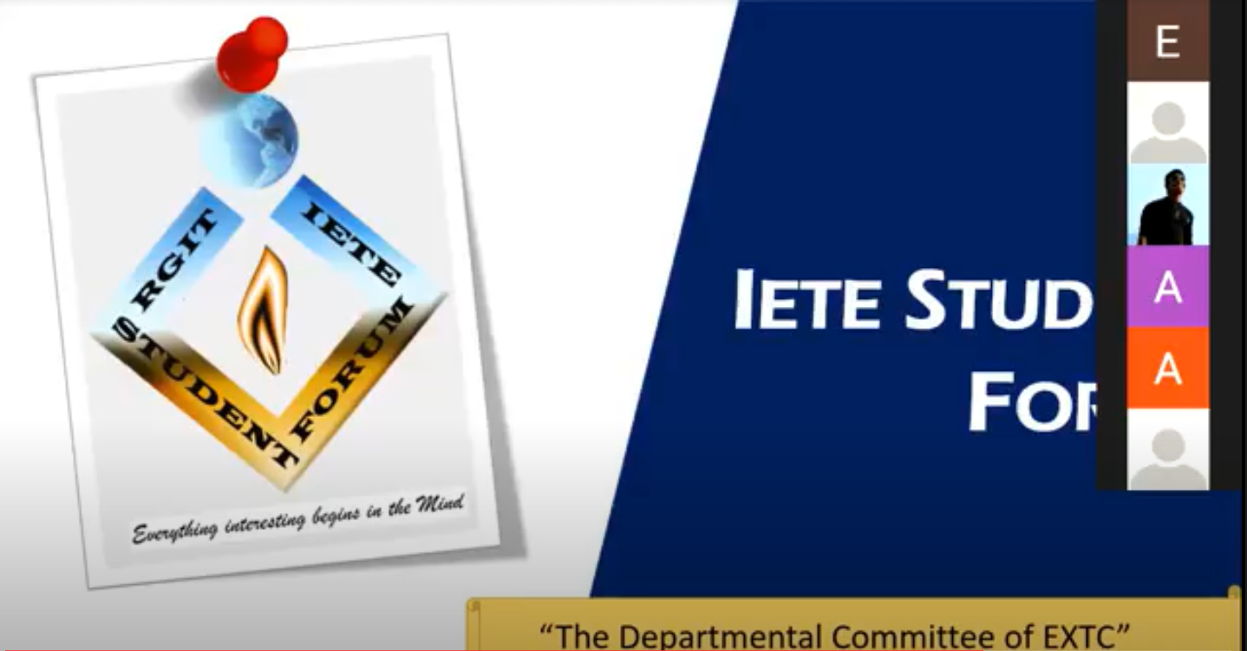

SE ORIENTATION
WEBINAR
FUNDAMENTALS OF ELECTRIC VEHICLES
5th March 2021
Speakers: Mr. Karan Gupta Total participant count: 100
Mr. Vinayak Bhat
IETE RGIT in collaboration with Team RGIT Racing together brought about a webinar on Fundamentals of Electric Vehicle which was conducted on 5th March 2021 on Zoom platform. The event was initiated by Ms.Chaitali(an IETE member) and Ms.Siddhi(an IETE member). Mr. Karan Gupta(Technical Head-IETE) and Mr.Vinayak Bhat(TR-racing member) were the speakers for the webinar.
The webinar commenced with the event host Ms.Chaitali addressing and greeting the professors and the audience. The webinar further continued with Mr.Vinayak introducing the students to electric vehicle. He further acknowledged the students about powertrain, types of powertrain, its uses, motors and motor controller. Topics including FS electric circuits and battery management system were also explained by him. Mr.Karan further explained the shutdown system, how it works ,BSPD and showed the simulation. The webinar covered topics from working of an electric vehicle to the career opportunities in this field.
The event subsequently moved on with the QNA session wherein all the doubts of the students were brought into light by Ms. Siddhi Vengurlekar. There were around 100 participants who got a chance to express their thoughts.
The webinar was then finally concluded with IETE chairperson Ms. Jahnavi Kodakandla delivering a small vote of thanks to the abiding audience and speakers present for the event.
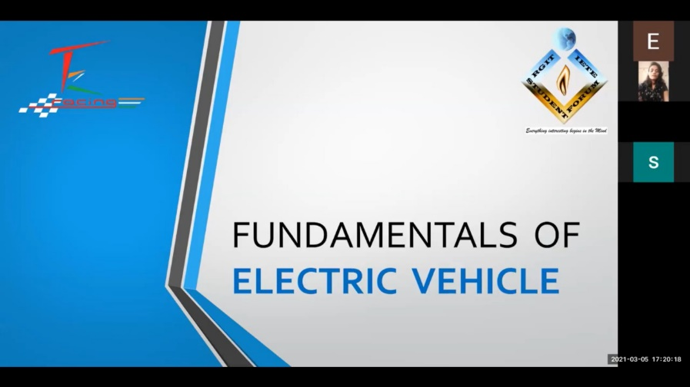

Fundamentals of Electric Vehicles via Zoom

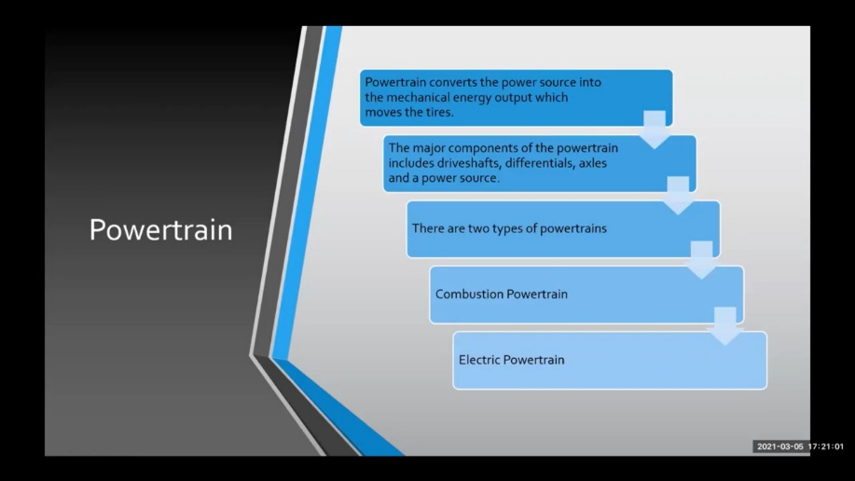

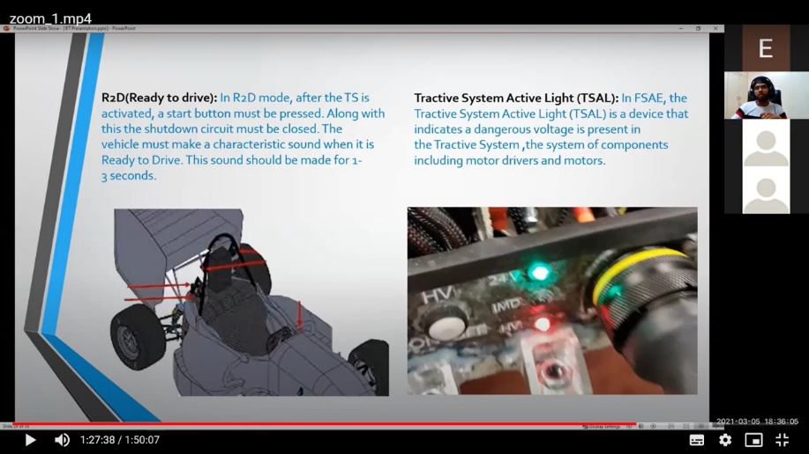

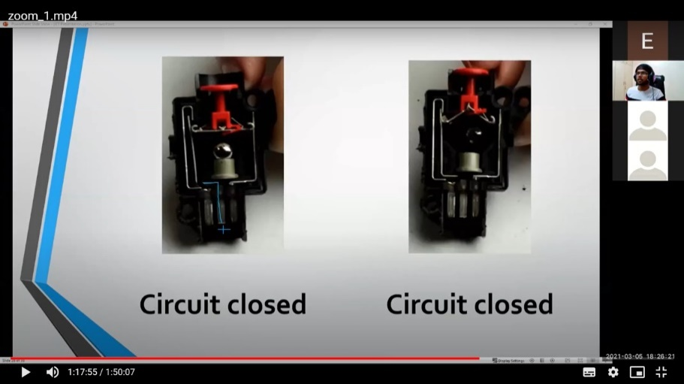

Mr. Karan Gupta and Mr. Vinayak Bhat describing about internal systems of an EV

BEGINNER’S TRAINING PROGRAM
WEB DEVELOPMENT
Day 1: 27th March 2021 Total participant count: 130
Day 2: 28th March 2021
Day 3: 3rd April 2021

BTP is an initiative where we train students to use various software and develop skillset. The very first theme of BTP was ADOBE PHOTOSHOP. The second theme of BTP was WEBDEVELOPMENT.
This BTP was conducted on 27th, 28thand 3rdApril 2021 on the Google Meet platform. The event was initiated by the event host Ms. Saylee Surve. Ms. Navya Sheregar and Ms. Pooja Palekar were speakers for the event. There were 130 participants present for the event. The interaction between participants and speakers made the event successful.
On the First day, introduction to frontend development, development tools/installation and Basics of HTML etc. were taught. The first day project was to make basic form using HTML only. All the doubts were cleared during the event. On the second day Styling using CSS was the topic and with that coming soon template project was done. On day three Bootstrap and grid system topic was explained with the last day project which was Designing of landing page. The topics covered in all three sessions were summarized in the last session and all the doubts were cleared by Miss. Navya
Every day participants cleared their doubts with speakers. The event ended with Ms. Jahnavi Kodakandla delivering a vote of thanks to all the participants present for the event.
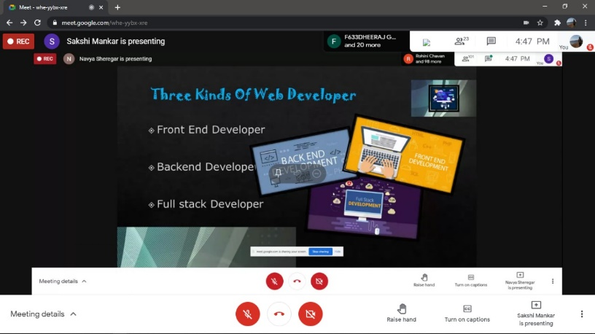

BTP on Web Development by IETE members via Google Meet

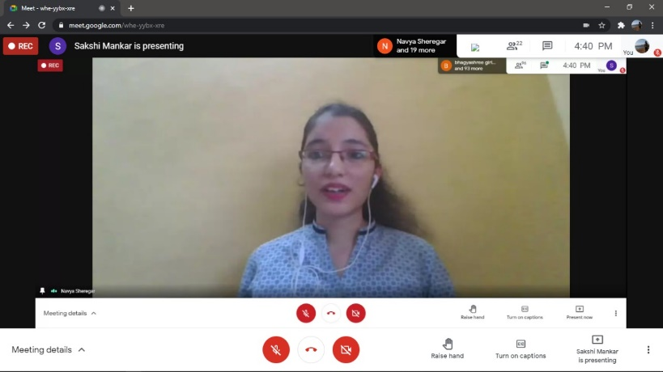

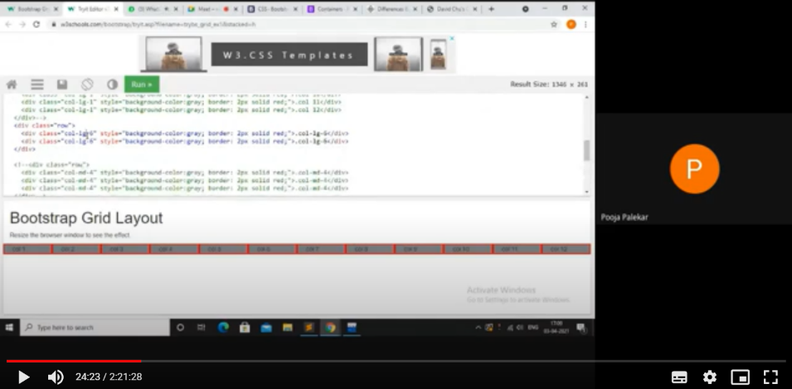

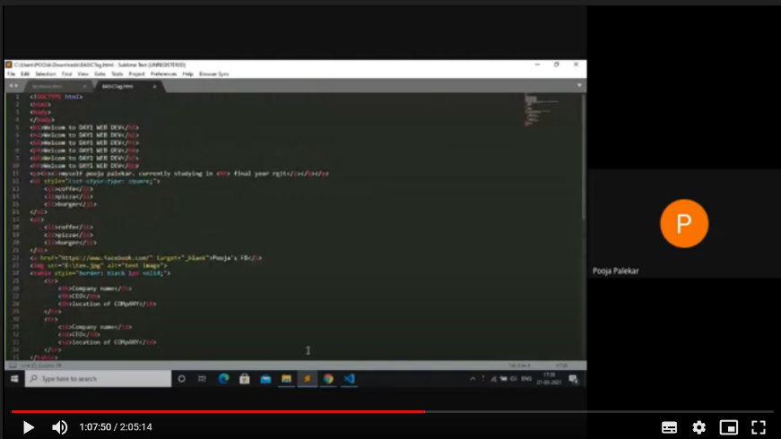

Miss Navya Sheregar and Miss Pooja Palekar; IETE members; conducting the session
and teaching about Web Development from scratch

Events conducted during 2019-2020

Sr.no | Name of the Events | Date | Speaker | About the event
1 | SE orientation | 24-07-2019 | Dr. S. D. Deshmukh | Second year students were briefed about the Department
2 | Texas IOT workshop | 19-08-2019 &  20-08-2019 | Prof. SahistaKhanum | Upcoming IOT trends were explained along with hands on practice.
3 | Proteus Software Workshop | 20-08-2019 | Vishal Thorat, Hitesh Humane, Nitesh Patel | Students were briefed about Proteus Software.
4 | Multisim Workshop | 06-09-2019 | Nitesh Patel, Hitesh Humane | A tutorial about Multisim workshop was conducted.
5 | Python Workshop | Stage  1:04-09-2019  2:01-10-2019 | Prof. Piyush Dave | Python was taught from scratch for the students.
6 | HFSS  Workshop | 04-02-2020 | Prof.S..R..Bhoyar | Students were given a brief about HFSS software used for antenna design
7 | Latex Workshop | 10-02-2020 | Mr. Sandeep Julai | Final years students were briefed about the latex software
8 | LTspice Workshop | 17-02-2020 | IETE members | SE students were given a idea about the software

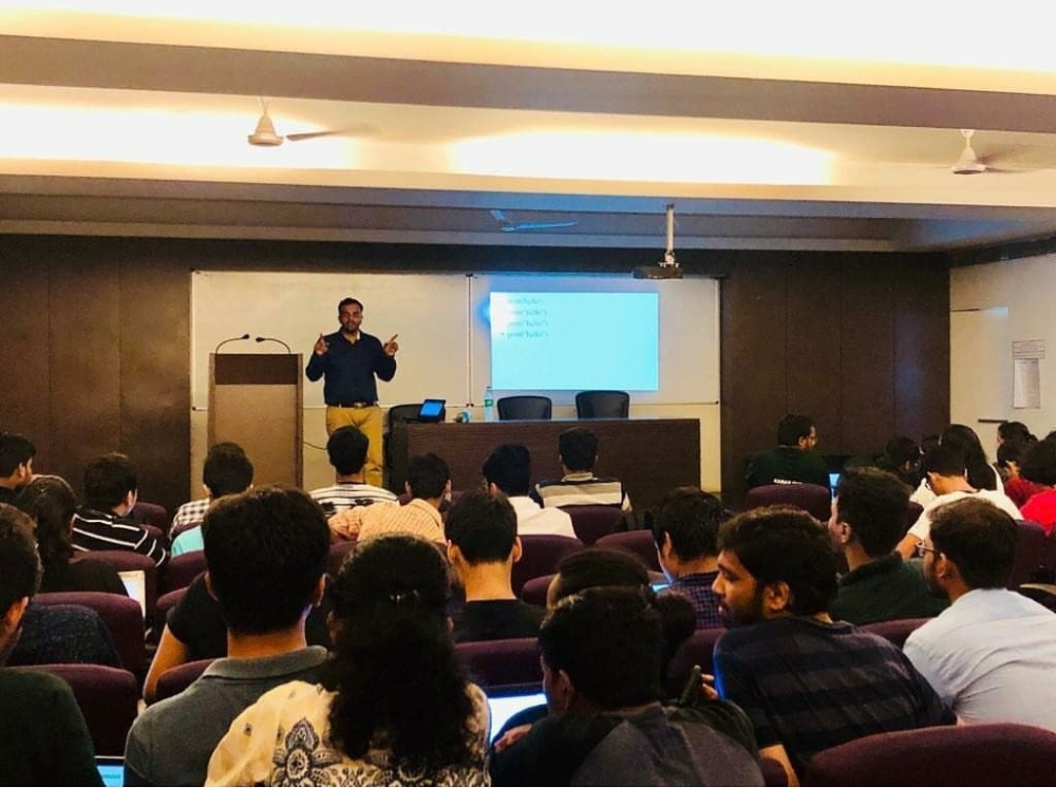
Python workshop
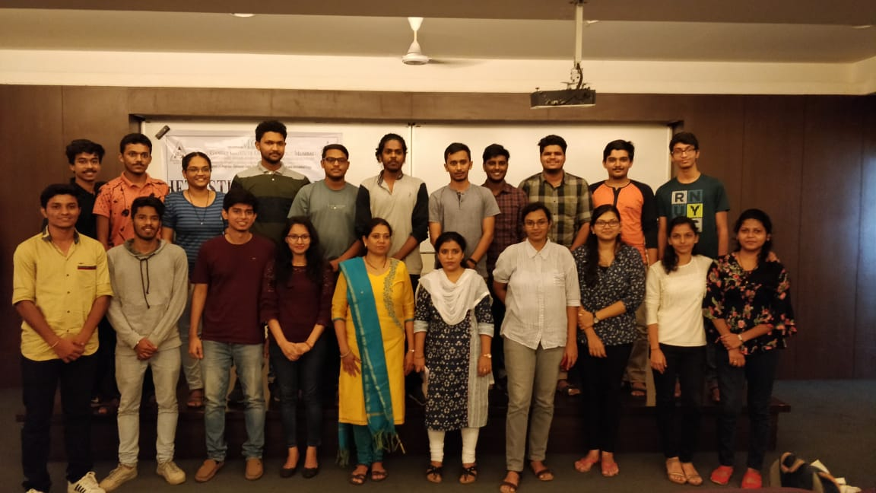
Texas IOT workshop
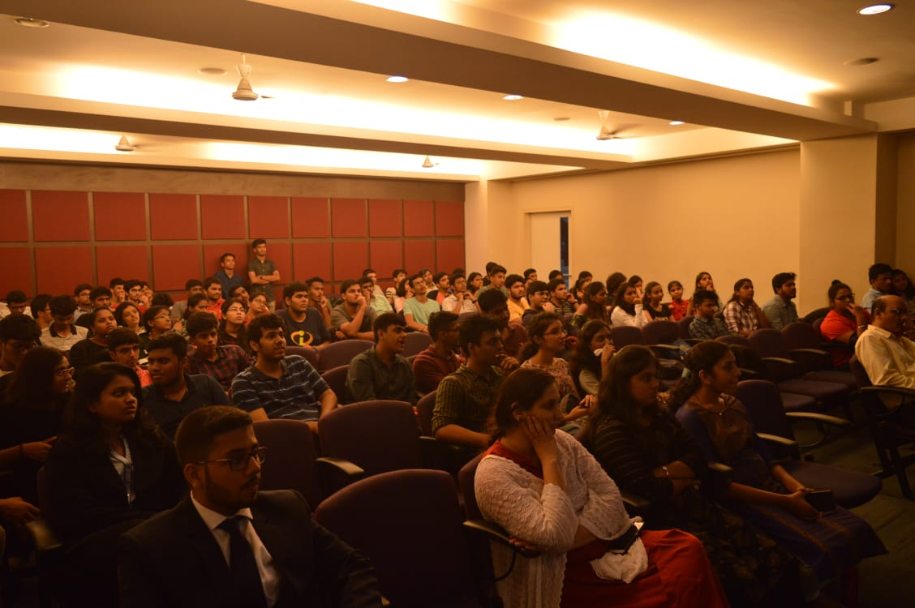
Proteus Workshop
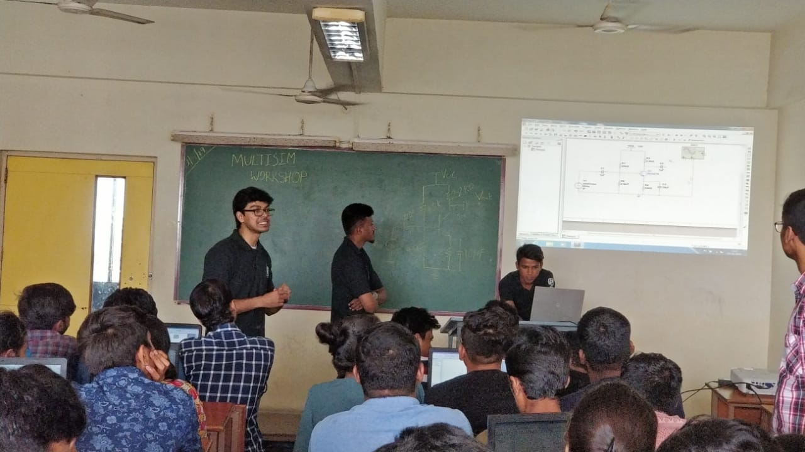
Multisim Workshop

